# DATABASE SYSTEM PRACTICUM REPORT

# MODULE 6

**QSV**



**CREATED BY :**

**KURNIAWAN BAGASKARA**

**L200214253**

# INFORMATICS STUDY PROGRAM

**FACULTY OF COMMUNICATION AND INFORMATION SCIENCE MUHAMMADIYAH SURAKARTA UNIVERSITY**

1. 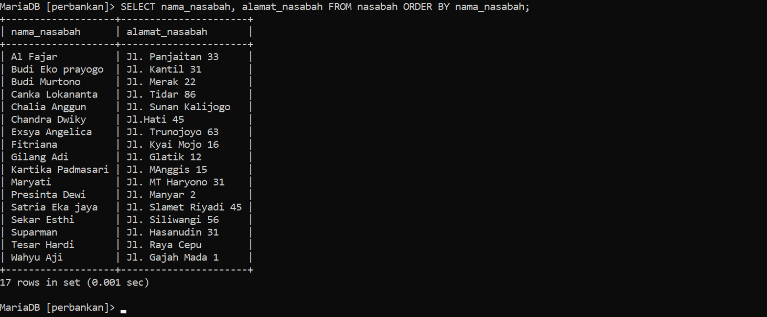
2. 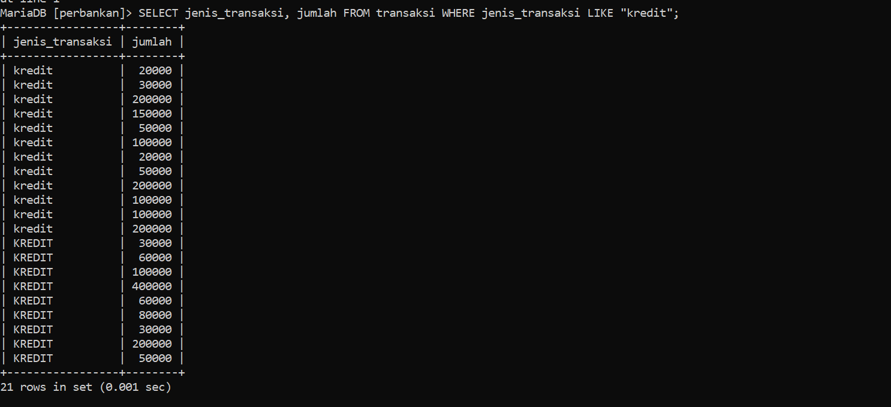
3. 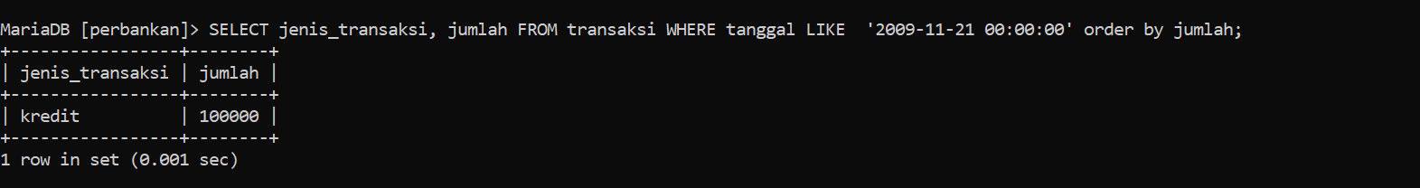
4. 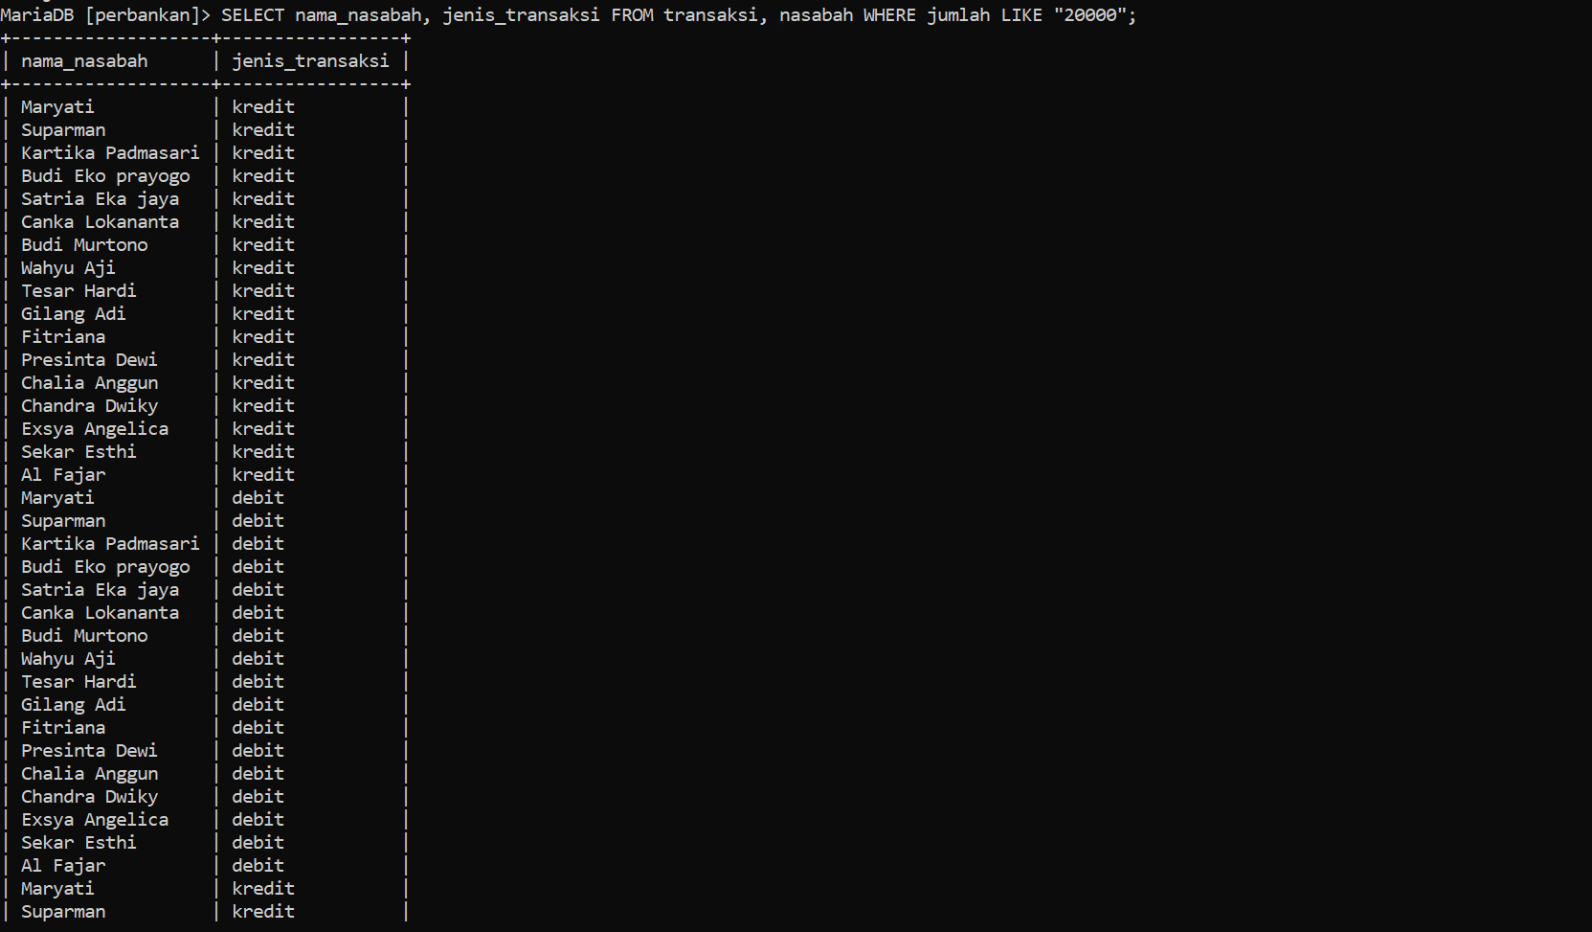
5. 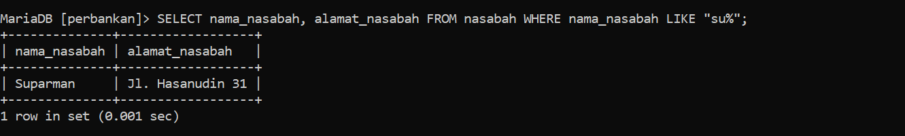
6. Looking for customer_id with a number above "20000"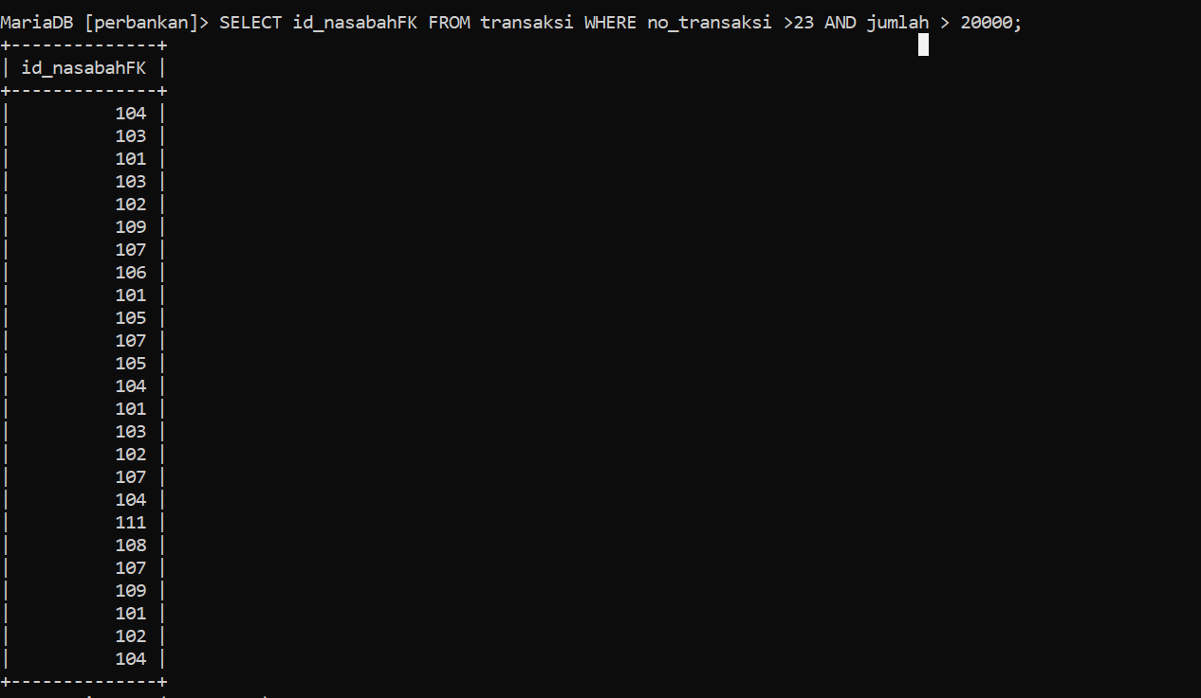
7. Search for a sum with 3 conditions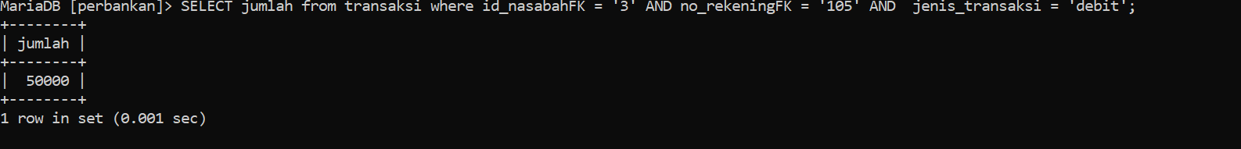
8. Display customer names and customer addresses sorted from customer names according to the first alphabetical order, then skip the first 2 rows, and take only 4 data.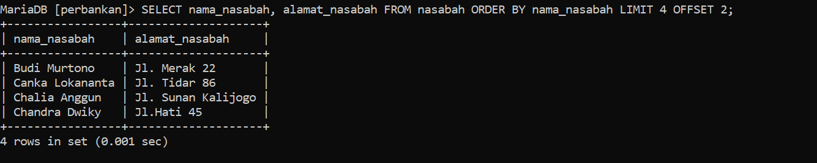
9. Display the customer's name and customer's address where the customer's name begins with “Bu” and the customer's address is not NULL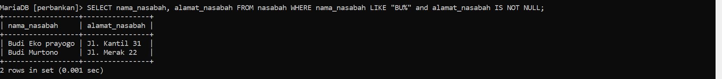
10. Display the customer's name and customer address where the customer's name begins with 'Bu' and and the customer's address is not NULL sort by customer name limit to 8 data only and skip the top 2 data